**Science Worksheet**

**Grade 3**

**Chapter: Living on the earth**

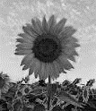**Q1: Describe the movement of different living things next to the pictures given below.**

**1. ______________________________________**

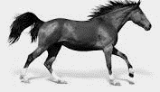

**2. ­­­­­­­­­­­­_____________________________________**



**3. ­­­______________________________________**

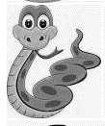

**4. ­­­­­­­­­­______________________________________**

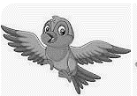

**5. ­­­­­­­­­_______________________________________**

**Q2: Match the adults with their young ones.**

**1. duck kitten**

**2. man duckling**

**3. fish plant**

**4. seed baby**

**5. cat fry**

**Q10: Write the correct group of animals under the pictures given below.**



  